HACETTEPE UNIVERSITY DEPARTMENT OF

COMPUTER ENGINEERING

BBM 453 LAB EXPERIMENT



Mehmet Taha USTA – 21527472

Çağlar USLU – 21808388

Group No: 4

1. **You should use one router, one switch and at least one PC for your group, and plug required cables and activate required connections. So you are going to create your own local area network with Router as a gateway. In the next lab, you're going to connect your groups and create a WAN (wide area network) as seen in Figure-2.**

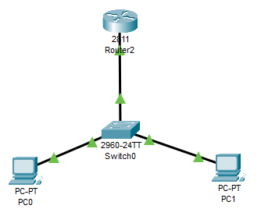

All connections have been made correctly. All connections are green lights.

1. **You should enter enable mode if you want to configure anything on router. Show commands can be used in user or enable mode (outside of config mode). You can also use ? symbol for displaying usable commands in that mode and their simple explanations.**

Group id is 4, we set the IP’s again.

From 10.100.1.254 to 10.104.1.254



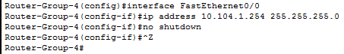

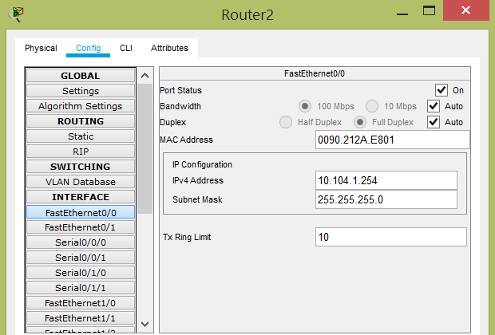

1. **If there is any configuration settings stored in your Router, which may be left from previous lab sessions, you have to reset your router to factory default setting according to Cisco procedures documented in files in FTP directory of the course.**

All necessary adjustments have been made from scratch.

1. **First you have to give appropriate names to your Router, according to your section/group number using hostname command**

Our group id is 4.

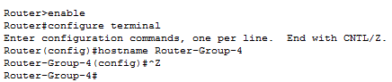

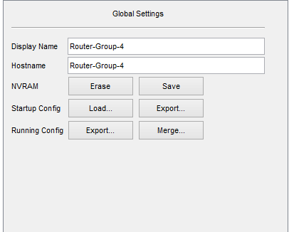

1. **In this step, each group runs simple show commands, snapshot and discuss the results.**

**Show version:**

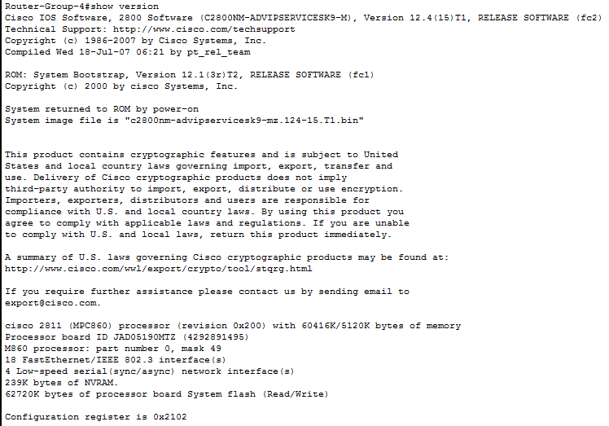

**Show running-config:**

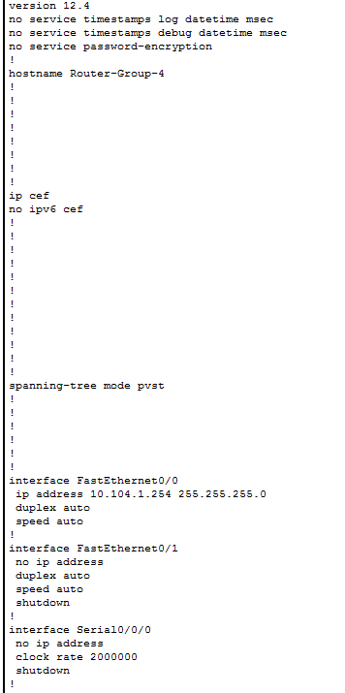

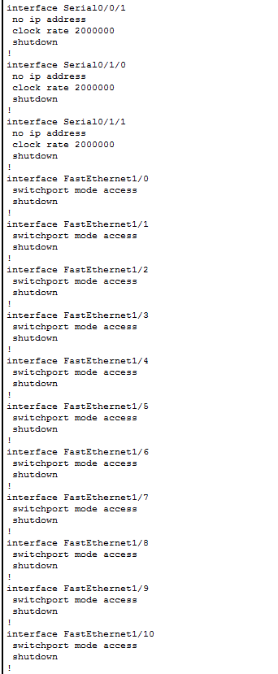

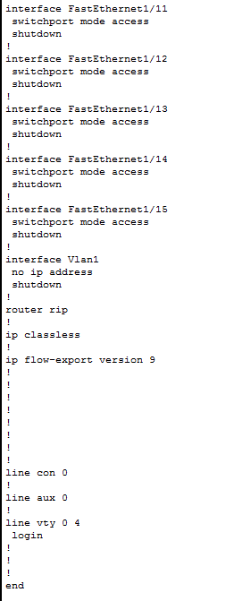

**Show startup-config:**

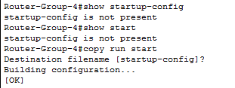

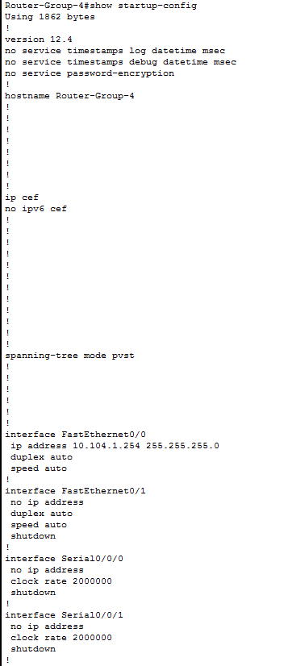

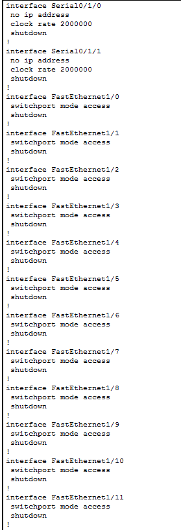

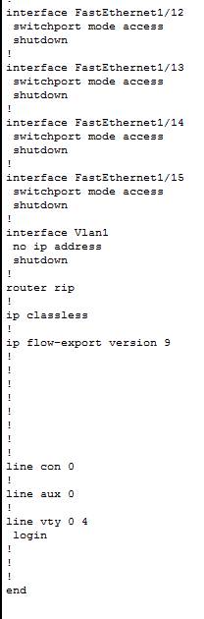

**Show users:**

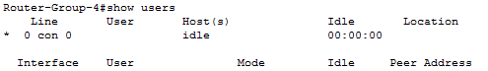

**dir all-filesystems:**



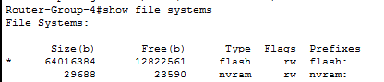

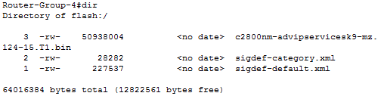

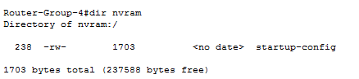

**Show interfaces:**

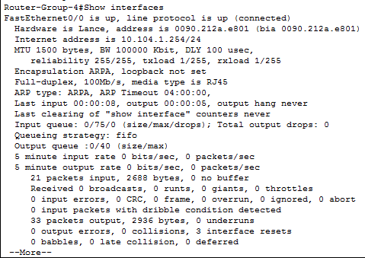

**Show ip interface brief:**

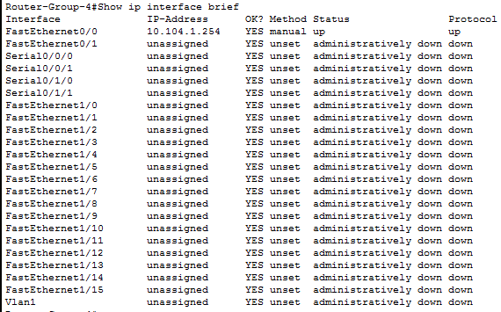

1. **Configure IP address of your PC and Router according to Figure 2 - Lab Topology.**



1. **Finally you are able to ping in both ways (PC to Router, Router to PC), if every cable connections and IP configurations are correct.**

**Pc0 = 10.104.1.1**

**Pc1 = 10.104.1.2**

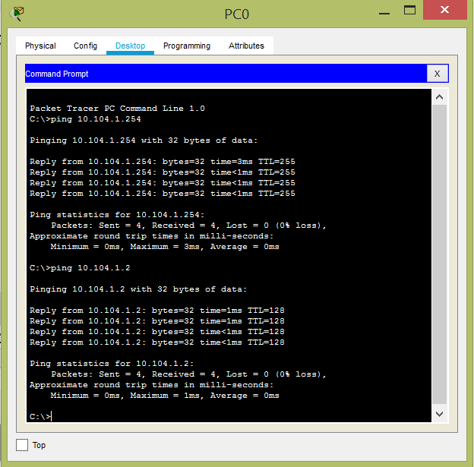

**Router = 10.104.1.254**

